WEEK 3 MACHINE LEARNING MODEL DEVELOPMENT PLAN
E-Commerce Customer Churn Prediction — Python
Strategic planning document for model selection, training, evaluation and deployment

1. Introduction and Problem Definition
Machine learning (ML) is used to learn patterns from historical data and use those patterns to make predictions on new observations. In this project, the hypothetical business problem is E-Commerce Customer Churn Prediction: predicting whether a customer is likely to stop purchasing from an online store. The model would support the business in identifying customers who may need timely retention actions.
The problem is suitable for machine learning because customer behaviour can contain several interacting signals, such as purchase frequency, total spending, recency of the last purchase, number of returns, review behaviour, engagement, and customer tenure. A classification model can combine these signals and estimate a churn probability for each customer. The project is hypothetical, so no real dataset or code execution is required in this Week 3 planning task.
Business motivation: retaining an existing customer can be more useful than treating every customer in the same way. A predictive system could help a business prioritize retention campaigns, reduce unnecessary outreach, and make decisions using measurable customer behaviour rather than intuition alone.

2. Project Objectives and Scope
The primary objective is to design a complete and realistic machine learning pipeline that can later be implemented in Python. The plan is to compare appropriate classification algorithms, prepare the data correctly, tune the selected model, evaluate it using multiple metrics, and define a conceptual path for deployment and monitoring.
- Predict a binary target: Churn = Yes/No.
- Identify useful behavioural features and avoid data leakage.
- Build a preprocessing pipeline for missing values, categorical variables and numerical features.
- Compare baseline and stronger candidate classification models.
- Use cross-validation and hyperparameter tuning to select a robust model.
- Evaluate the final model using accuracy, precision, recall, F1-score and ROC AUC, with emphasis on recall/F1 for churn detection.
- Define how the model could be deployed, monitored and retrained when real data becomes available.

3. Scope and Out-of-Scope Items
In scope: customer-level churn classification, data quality checks, feature engineering, preprocessing, model comparison, validation, performance evaluation, explainability considerations, and a conceptual deployment plan.
Out of scope for this assignment: collecting a real customer dataset, executing model training, building a production API, connecting to a live database, running a marketing campaign, and making financial decisions from real customer information. These can be future implementation stages.

4. Data Preprocessing Strategy
Before training, the dataset would be inspected to understand its columns, data types, missingness, duplicate records, unusual values, and target distribution. The target label must be defined clearly and should represent a measurable future churn event. Features that would only become known after the churn event must be excluded to prevent leakage.
- Data cleaning: remove exact duplicates, correct invalid values, standardize category labels, and verify ranges such as non-negative spending and valid order counts.
- Missing values: measure missingness by column, determine whether missingness has a business meaning, and use suitable imputation. Numerical fields may use median imputation; categorical fields may use the most frequent category or an explicit 'Unknown' class.
- Encoding: convert categorical variables into model-ready numerical form, using one-hot encoding for nominal categories where appropriate.
- Scaling: standardize numerical features when required by distance-based or linear models. Tree-based models generally do not require feature scaling.
- Feature engineering: create meaningful variables such as average order value, purchase frequency, recency bands, return rate, spending per order, and customer tenure, while ensuring every feature uses information available before the prediction point.
- Feature selection: remove identifiers and irrelevant variables, inspect correlations and redundancy, and use model-based importance or permutation importance after establishing a baseline.
- Class imbalance: inspect the churn/non-churn ratio. If imbalance is substantial, consider class weights or resampling methods and evaluate using metrics that do not hide poor minority-class performance.

5. Model Selection and Training Strategy
The project will begin with a simple baseline model and then compare more capable algorithms. The chosen model should not be selected only because it has the highest accuracy; interpretability, recall, F1-score, ROC AUC, stability, training cost, and business usefulness should also be considered.
Candidate model | Purpose | Strength | Possible limitation
Logistic Regression | Baseline classifier | Simple, interpretable, fast | May miss complex non-linear relationships
Decision Tree | Interpretable non-linear model | Easy to explain; captures interactions | Can overfit without regularization
Random Forest | Ensemble comparison | Strong general-purpose performance; robust | Less transparent than one tree
Gradient Boosting | High-performance candidate | Captures complex patterns effectively | Needs careful tuning; less simple to explain
Recommended approach: use Logistic Regression as the baseline and compare it with Decision Tree, Random Forest and Gradient Boosting. A final candidate would be selected after cross-validation and tuning. For an imbalanced churn problem, class weights and threshold selection should be considered instead of automatically using a 0.50 probability threshold.
Training process: split the dataset into a training portion and a final hold-out test set. Fit preprocessing only on the training data. Use a scikit-learn Pipeline and ColumnTransformer so transformations are learned inside each cross-validation fold and leakage is minimized.

6. Hyperparameter Tuning
After establishing baseline performance, hyperparameters would be tuned using GridSearchCV or RandomizedSearchCV with stratified cross-validation. Examples include tree depth, minimum samples per leaf, number of trees, learning rate, number of estimators, and regularization strength. Randomized search can be preferred when the search space is large. The tuning objective should reflect the business goal, such as F1-score or recall, rather than accuracy alone.
The test set must remain untouched during model selection. It should be used only once, or as sparingly as possible, for the final unbiased performance estimate after the model and threshold have been finalized.

7. Evaluation Metrics
- Accuracy: proportion of all predictions that are correct. Useful as a general measure but can be misleading when churn classes are imbalanced.
- Precision: among customers predicted as churners, the proportion who actually churn. Higher precision reduces unnecessary retention actions.
- Recall: among customers who actually churn, the proportion correctly identified. High recall is valuable when missing a likely churner is costly.
- F1-score: harmonic mean of precision and recall. It provides a balanced single score when both types of error matter.
- ROC AUC: measures how well the model ranks positive cases above negative cases across classification thresholds. It is useful for comparing discrimination before choosing a business threshold.
- Confusion matrix: shows true positives, true negatives, false positives and false negatives, making the model's errors easier to interpret.
For this churn use case, recall and F1-score should receive strong attention because failing to identify a real churner may reduce the effectiveness of retention efforts. Precision should also be monitored so that the business does not contact too many customers unnecessarily.

8. Validation Strategy
Stratified K-fold cross-validation should be used for classification so that each fold maintains a similar class distribution. A five-fold design is a practical starting point: the training data is divided into five parts, the model trains on four parts and validates on the remaining part, and this is repeated until every part has served as validation data. The mean and variation of the validation metrics provide a more reliable view than a single split.
If the eventual real-world problem has a strong time component, a time-based validation design should be considered instead of random splitting. This prevents future information from being used to predict the past and better simulates production conditions.

9. Model Interpretability and Error Analysis
After selecting a candidate, analyze which features influence predictions and where the model makes mistakes. Feature importance, permutation importance, or suitable explainability techniques can be used. The confusion matrix should be examined for false positives and false negatives. Error analysis may reveal data-quality problems, missing segments, or groups of customers for whom the model performs poorly.
The model should be treated as a decision-support tool rather than an automatic decision-maker. Predictions should be reviewed against business rules and ethical requirements, especially when customer outcomes could be affected.

10. Conceptual Deployment and Maintenance
Although deployment is optional in this assignment, the eventual architecture could consist of a trained model saved with its preprocessing pipeline, an application or API receiving customer features, a prediction service returning churn probability, and a database or dashboard storing predictions and monitoring information.
Maintenance would include monitoring input-data quality, missing-value rates, feature distributions, prediction distributions, model performance when labels become available, and data drift. Retraining can be scheduled when performance falls below an agreed threshold or when customer behaviour changes materially. Model versions, training data periods, hyperparameters and evaluation results should be recorded for reproducibility.

11. Potential Challenges and Mitigation
Challenge | Mitigation
Data leakage | Exclude post-churn information and fit transformations only inside the training pipeline.
Class imbalance | Use stratified validation, class weights/resampling where appropriate, and report precision/recall/F1.
Overfitting | Use cross-validation, regularization, pruning, ensemble controls and a final hold-out test set.
Missing or inconsistent data | Profile missingness, validate ranges, standardize categories and document assumptions.
Changing customer behaviour | Monitor drift and retrain when justified by evidence.
Low interpretability | Prefer interpretable baselines and supplement complex models with feature-importance/explainability analysis.
Wrong decision threshold | Choose the threshold using validation data and business costs rather than assuming 0.50.

12. Python Libraries and Tools
Tool/Library | Contribution
Pandas | Data loading, cleaning, transformation and tabular analysis.
NumPy | Numerical operations and array-based calculations.
Scikit-learn | Preprocessing, pipelines, classification models, cross-validation and hyperparameter tuning.
Matplotlib / Seaborn | Model evaluation plots and supporting visual analysis.
Plotly | Interactive visualizations for later exploration or dashboards.
Jupyter Notebook / VS Code | Experimentation, documentation and development.
GitHub | Version control, project documentation and sharing project artifacts.

13. Machine Learning Workflow Diagram
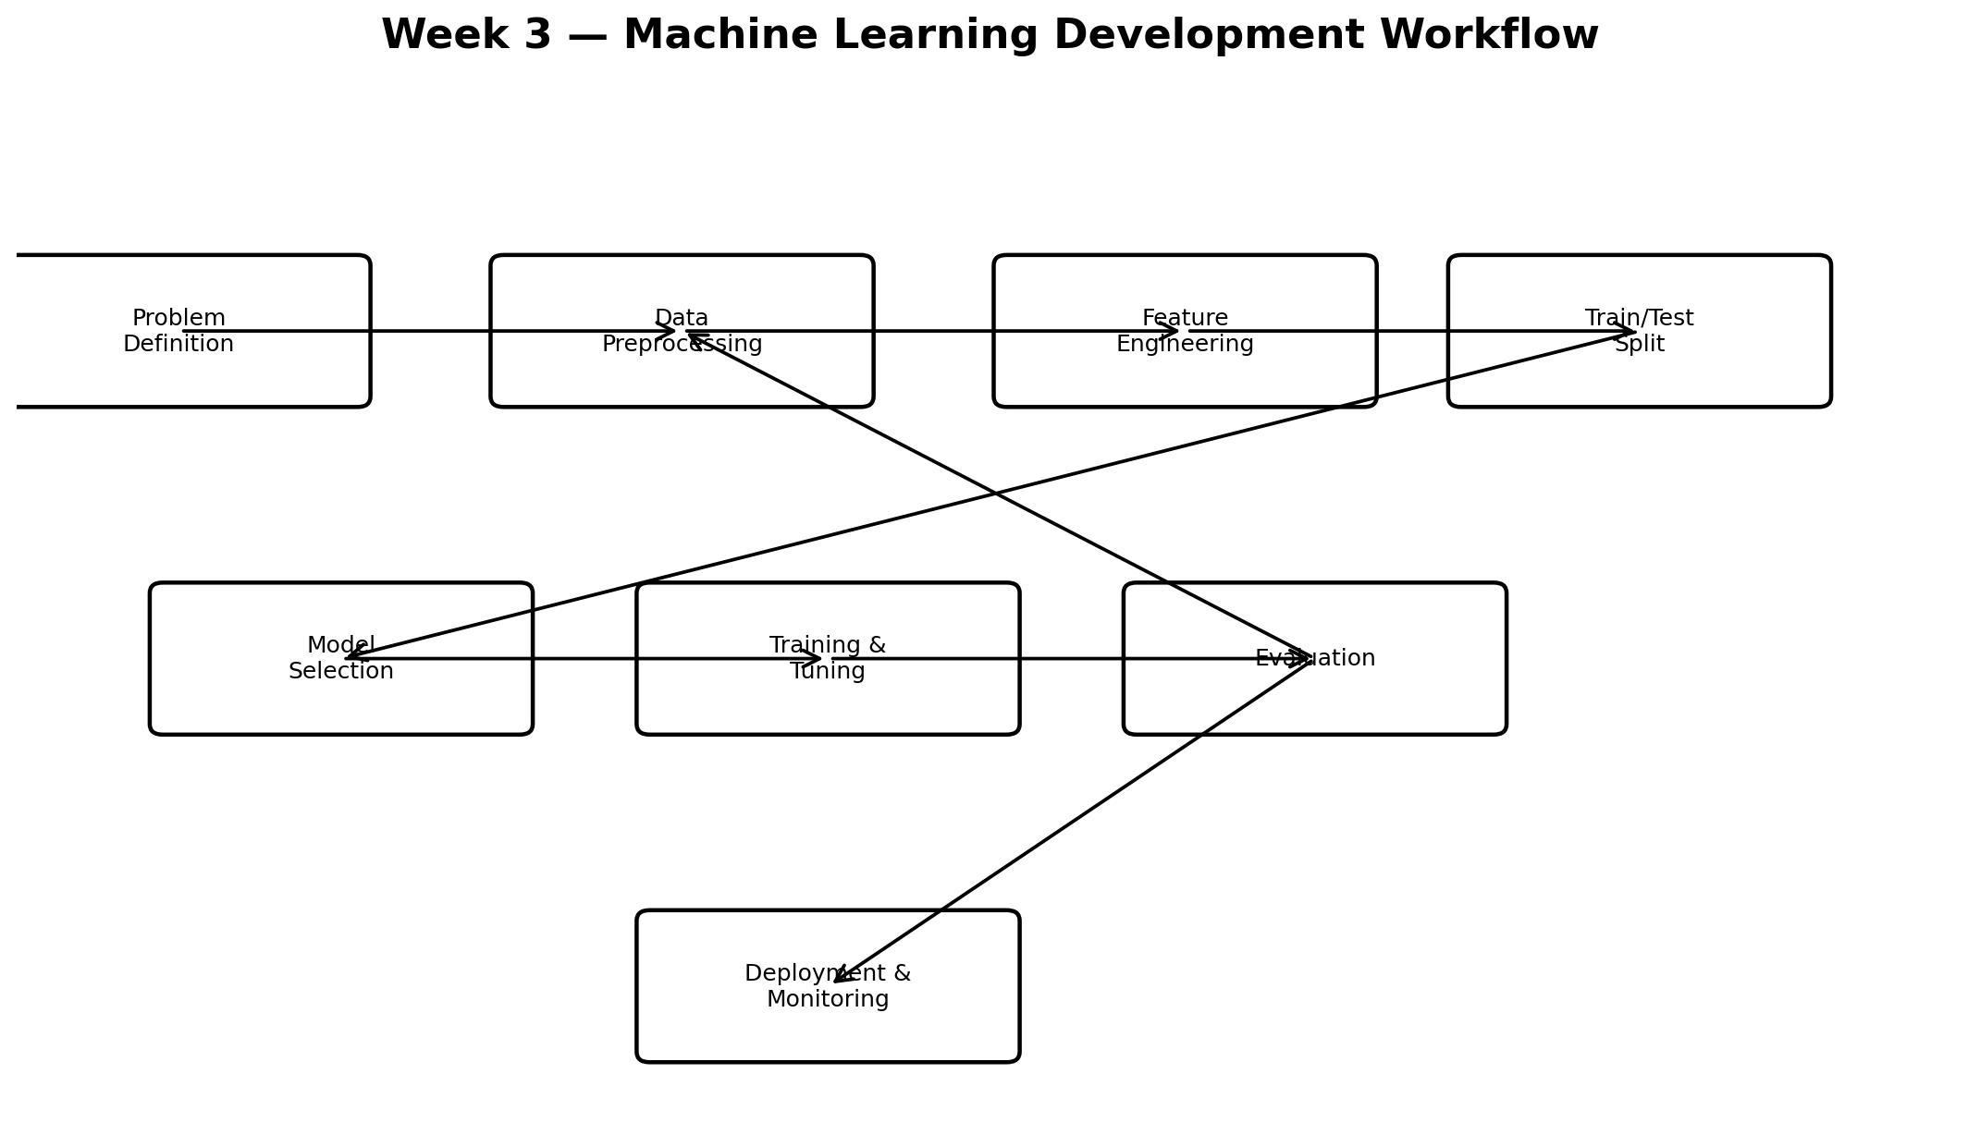
The workflow illustrates the complete path from problem definition through preprocessing, model selection, training, evaluation and eventual deployment. The feedback path from evaluation back to preprocessing represents iteration when performance or data quality is not satisfactory.

14. Evaluation and Validation Diagram
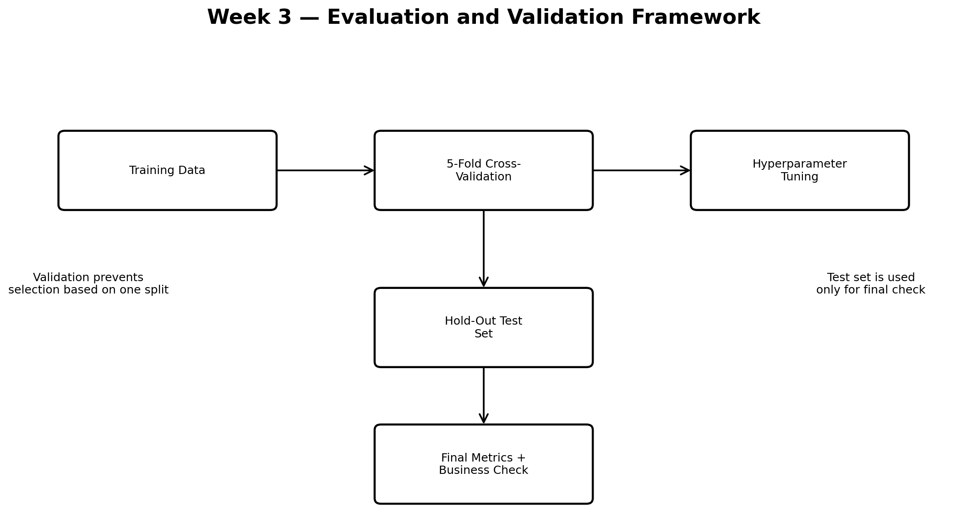
The validation framework separates model development from the final test assessment. Cross-validation supports tuning and comparison, while the untouched test set provides a final estimate after the model has been chosen.

15. 30–35 Hour Work Plan
Activity | Estimated time
Problem definition and success criteria | 3 hours
Data assumptions and preprocessing plan | 5 hours
Feature engineering and feature selection strategy | 4 hours
Candidate model research and selection | 4 hours
Training and hyperparameter tuning plan | 5 hours
Evaluation metrics and cross-validation strategy | 4 hours
Deployment and monitoring plan | 3 hours
Diagrams, documentation and final review | 5 hours
Total planned effort: 33 hours. The schedule is intentionally approximate and can be adjusted after real data and technical constraints are known.

16. Expected Outcomes
- A clearly defined machine learning problem and success criteria.
- A reproducible preprocessing and modeling architecture suitable for later Python implementation.
- A justified comparison of baseline and ensemble classification approaches.
- A validation strategy that reduces overfitting and provides reliable performance estimates.
- A balanced evaluation framework covering accuracy, precision, recall, F1-score, ROC AUC and confusion-matrix analysis.
- A conceptual deployment and monitoring plan for maintaining the model after release.
- A structured technical document that can guide the implementation stage in future weeks.

17. Conclusion
This Week 3 plan translates the customer churn problem into a complete machine learning development strategy. It covers problem definition, preprocessing, feature engineering, model selection, training, hyperparameter tuning, evaluation, validation, interpretability, deployment and monitoring. The approach emphasizes reproducibility and prevention of data leakage, while recognizing that the best model is not necessarily the most complex one. Once a real dataset is available, this plan can be converted into executable Python code using scikit-learn and related libraries. The final objective is to build a model that is technically reliable and also useful for a real business decision process.

